Hyperion Speaking Points – International Interview 2026

Software: (2m)
- How our Bluetooth LOGIC works (what causes a switch) (30s) - Sam
- How our Light System / Out Avoidance Works (30s) - Tom
- What our Main Strategy Logic Is (1m) – Sam & Tom

Hardware: (2m)
- A
- B
- C
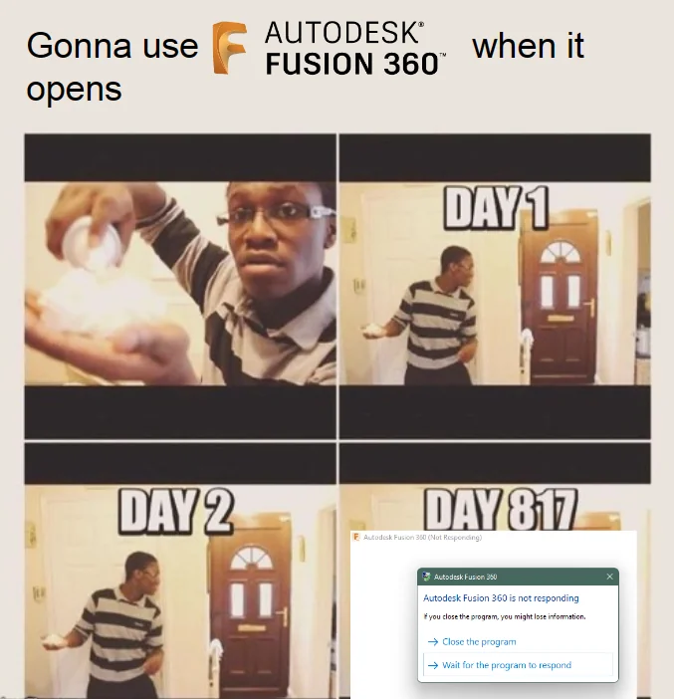
Electrical: (2m)
- A
- B
- C

Overflow – 1m

